PRESS RELEASE: for immediate release
6 July

The English-Speaking Union welcomes Keir Starmer’s plans for oracy in school curriculum

The English-Speaking Union, a charity working with schools to improve children’s speaking and listening skills, has welcomed Sir Keir Starmer’s announcement today that Labour will put oracy into the school curriculum, so every child learns how to express themselves.
The English-Speaking Union is an international membership and education charity which works with teachers and schools to support the development of all children’s speaking and listening ability (oracy) and cross-cultural understanding as a foundation skill for life.
Annabel Thomas MacGregor, Director of Education at the English-Speaking Union, says: “Oracy is a skill for life. Our aim is for oracy to be incorporated into the curriculum in the same way that maths or literacy is, as we believe these skills are fundamental to academic and personal success. Oracy is essentially the ability to communicate well, to articulate your thoughts, to be able to speak clearly to a range of audiences and in a range of contexts with confidence. It’s also about being able to agree to disagree, respecting other people’s opinions and using verbal skills to make your mark on the world.
“As an education charity, the English-Speaking Union is passionate about social mobility and equality and ensuring that all children have the chance to thrive and to reach their full potential through effective speaking and listening skills.”
Jane Easton, Director-General at the English-Speaking Union, added “As the CEO of a charity which provides Oracy programmes for schools, I can vouch for the transformational power of teaching speaking and listening skills to enhance articulacy and confidence. These skills should not be the preserve of the few. We owe all young people the opportunity be taught Oracy to support literacy and numeracy in schools, and to equip them for every aspect of their lives.”
Following a successful pilot and building on its successful ‘Discover Your Voice’ workshops for schools, the English-Speaking Union has recently launched ‘Oracy in Action’, a comprehensive programme of lesson plans and resources for primary schools.
For further information please see https://www.esu.org/oracy-in-action/

ENDS

Photo:
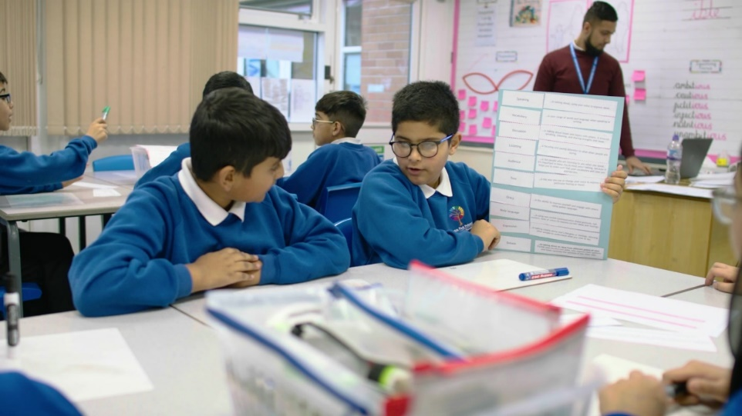
Pupils at Horton Park Primary School in Bradford who piloted Oracy in Action.
Credit: English-Speaking Union

For media interviews and further information please contact:
Bernadette Mooney, PLMR Genesis, bernadette.mooney@genesispr.co.uk or call 01473 326346
Nicole Hogger, PLMR Genesis, nicole.hogger@genesispr.co.uk

“We have definitely seen the positive impact”
Case Study for Oracy in Action.
Horton Park Primary School, part of the Exceed Academies Trust, in Bradford East took part in the 2022 pilot of Oracy in Action. 37 languages are spoken at the school which is situated in one of the most disadvantaged areas of Bradford. The majority of students have a South-East Asian heritage.
Deputy Headteacher and English lead at Horton Park Primary School, Laura Naylor, said “Since we introduced Oracy in Action, we have definitely seen the positive impact amongst our pupils, particularly our Year 6 pupils who have developed in confidence over the programme. They are now more confident in articulating their viewpoints. Oracy in Action has demonstrated that there is impact being shown over time too, for example, a pupil who was reserved and shy, volunteered for the Shakespeare in Schools project for a lead role!”
Zakir Rehman, a Key Stage Two Teacher, said: “From a practical point of view I really liked the delivery. There was no extra workload for the teachers, the PowerPoints were all prepared and lesson plans were already made. The aim is to see oracy as part of everything and integrated into everything. The quality resources were well considered and pitched for all pupils, regardless of ability or needs.”
Zakir added: “I have seen many other benefits, within the classroom and beyond. The pupils are able to effectively express themselves about how they’re feeling. They can also share opinions, listen to one another and disagree politely. It can be used across the curriculum for discussion and debates.”
Key Stage Two pupil Zakia said: “Oracy is important because it helps us to understand each other. It builds up your confidence for when you grow older, and you want to do a job.
Fellow pupil Blake added: “I enjoyed Oracy in Action because it helps you build confidence, and it can help you later on in your life.”
Annabel Thomas MacGregor, Director of Education at the English-Speaking Union said: “Our survey has found that too many children and young people are struggling to make friends or express how they feel because they haven’t had the opportunity to develop the speaking and listening skills (oracy) or gain the self-confidence for effective social skills which are a foundation for life. Oracy in Action has been designed as a complete oracy curriculum for Key Stages 1 and 2 with comprehensive, ready to go lesson plans and all supporting materials and resources. Following excellent feedback from the pilot we are delighted to make the programme available to schools nationally.”
For further information please see https://www.esu.org/oracy-in-action/

NOTES TO EDITORS
Survey
A survey commissioned by the charity found that children and young people aged 5-17 are struggling to make friends because they lack self-confidence in speaking to other children.
In the survey by Censuswide in May 2023, more than half of adults surveyed (52%) with children aged 5-9-years-old agree their child is struggling to make friends because they lack self-confidence in speaking to other children. Just under half of respondents (47%) with children aged 10-17-years-old agree their child is struggling to make friends for this reason.
Almost four in ten adults surveyed with children aged 5-9 (37%) or aged 10-17 (35%) said that school and nursery school closures during the Covid-19 pandemic had a negative impact on their child’s speech and language development. Almost three quarters (72%) of respondents with children aged 5-9 say their child has only partially or not at all regained the social skills they lost, while 7% with children aged 5-9 and 17% with children aged 10-17 say they have not regained them at all.
A lack of confidence in speaking and expressing themselves is also holding back the 16-24-age group. Seven in ten (71%) 16-24-year-olds surveyed agree their lack of confidence in speaking or expressing themselves is holding them back. Almost two thirds (63%) of respondents this age, say they always or often struggle to find the right words to express how they’re feeling. Almost nine out of ten (85%) respondents of this age who did not receive any public speaking/debate training in school or do not remember if they did, think receiving specific support at school for speaking and listening (oracy), would have helped them progress better in their career and life generally.
The research was commissioned by the English-Speaking Union and conducted by Censuswide with a sample of 2,041 general population in England, 18 years old +, 50% of which are parents/grandparents. The survey fieldwork took place between 19.05.2023 - 23.05.2023. Censuswide abide by and employ members of the Market Research Society which is based on the ESOMAR principles and are members of The British Polling Council.
The English-Speaking Union
The English-Speaking Union is an international membership and education charity which works with teachers and schools to support the development of children’s speaking and listening skills (oracy) and cross-cultural understanding as a foundation for life and for learning. Its programmes including ‘Discover Your Voice’ workshops and national oracy and debating competitions teach students to be confident talkers and attentive listeners, and as they get used to speaking in class and learn to treat other people’s opinions with respect, their self-confidence and self-awareness grows. Effective speaking and listening as a foundation education skill also enables students to improve their understanding and deepen their knowledge of any subject matter through talking and discussion in class.
Other surveys
The 2021 Oracy All-Party Parliamentary Group Inquiry, Speak for Change, reported two thirds of primary teachers (69%) and nearly half of secondary teachers (44%) said school closures had a negative effect on the spoken language development of students eligible for pupil premium, compared with 1 in 5 teachers for their most advantaged pupils.
Research by The Sutton Trust showed that 97% of teachers, 94% of employers and 88% of young people believe that life skills such as confidence, motivation, resilience and communication are as or more important than academic qualifications.
About Oracy in Action
Oracy in Action is an exciting series of ready-made lesson plans and activities for primary school teachers to support the development of speaking and listening skills in Key Stage 1 and Key Stage 2 pupils. Building on the English-Speaking Union’s long experience, advocacy and research, it provides clear and easy to use lesson plans and a structured approach to oracy in manageable steps.
- Fully sequenced, off-the-shelf, one-to three-term oracy programme which requires no further planning or preparation.
- Developed with leading education practitioners.
- Rooted in peer-reviewed evidence with direct links to the national curriculum.
- Provides a flexible approach to learning with modules which can be tailored to the needs of each classroom.
- Fits with School Improvement Plans and Ofsted priorities.
The pilot in 2022
Seven primary schools piloted Oracy in Action with 500 pupils between June and July 2022.
Schools in two geographic areas (Bradford and Taunton) with disproportionately higher rates of children eligible for Free School Meals (FSM) and English as an additional language (EAL) needs.
Each school delivered Oracy in Action – Module 1 (containing 36 lessons which are sequenced) to at least four different classes.
For further information please see https://www.esu.org/oracy-in-action/ or watch the film about Oracy in Action at Horton Park Primary School in Bradford https://youtu.be/3gdjCfcf5g4
- A full impact evaluation summary is available upon request.
Endorsements for Oracy in Action
Healthy debate is the absolute bedrock of a civilised society, and to have that, we need to be able to express ourselves well and to learn to listen to and understand the opinions of others. Oracy in Action teaches these vital skills, helping children become confident, engaged individuals, able to question and think critically about the world around them.
Anita Anand, journalist and author.
Communication skills will be increasingly important in a post-AI world, not only for those entering the workforce, but for citizens everywhere needing to make their voices heard. Oracy in Action is a vital step in ensuring that primary school children are taught the speaking and listening skills they need.
Dr Arlene Holmes-Henderson, Language Education Specialist, Associate Professor of Classics and Ancient History at Durham University & Senior Research Fellow, University of Sussex.
Finding the confidence needed to use your voices in new and different situations can be a daunting task. However, as a university lecturer and researcher, I have found that the ability to talk with and listen to individuals from a diverse range of backgrounds is crucial to developing new, innovative and collaborative ways of thinking about complex topics. Oracy in Action offers schools and young people the opportunity to develop the communication skills and, most importantly, confidence needed to speak up and make their very important voices heard.
Ellie Bristow, PhD researcher at Cardiff University, specialising in vocabulary development in the Centre for Language and Communication Research, a Fellow of the Higher Education Academy, a tutor on Cardiff University’s English language degree programme and an Associate Tutor on Cardiff Metropolitan University's Speech and Language Therapy degree programme.

Combines “Strongly agree” and “Somewhat agree”
Combines “Strongly agree” and “Somewhat agree”
Combines “Very negative” and “Slightly negative”
Combines “Strongly agree” and “Somewhat agree”
Combines “Would have significantly helped” and “Would have slightly helped”

